***Karan Kumar-Batch7-Assigment***

***Karan Kumar-(CEQ-539)***

***AWS SSM:***

AWS Systems Manager (SSM) is a fully-managed service that enables you to manage and automate operational tasks across your AWS resources. It provides a unified user interface for managing your Amazon Elastic Compute Cloud (EC2) instances, on-premises servers, and virtual machines (VMs), as well as other AWS resources such as Amazon Relational Database Service (RDS), Amazon Simple Storage Service (S3), and Amazon Elastic File System (EFS).

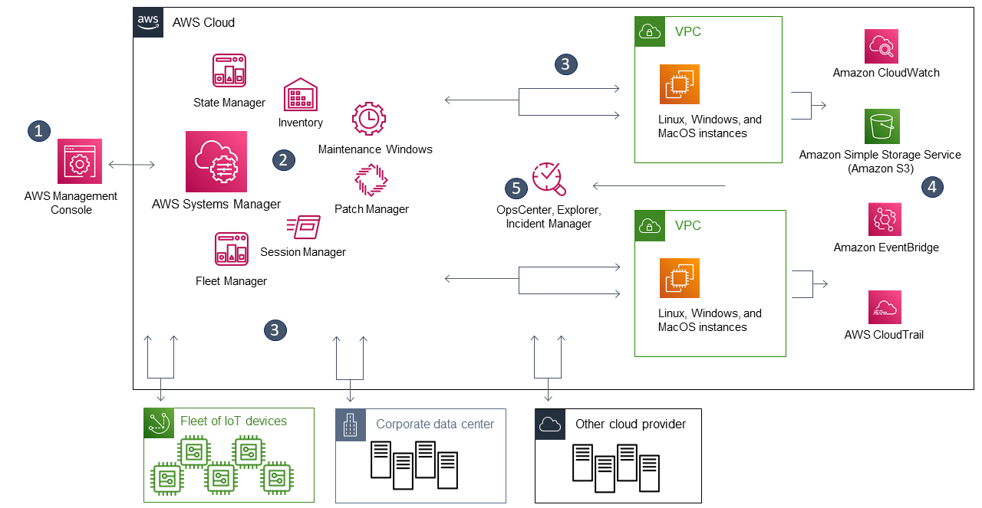

The following are some key features of AWS SSM:

1. **Inventory Management**: AWS SSM enables you to discover and track software and hardware components across your infrastructure. You can use SSM to retrieve a comprehensive list of installed software packages, network configurations, system configurations, and other resource details.
2. **Patch Management**: AWS SSM enables you to automate the patching of your instances and VMs with a few clicks. You can create patch baselines to define which patches to apply, when to apply them, and how to apply them.
3. **Run Command**: AWS SSM provides a way to run commands on a single instance, multiple instances, or entire fleets of instances. You can use Run Command to install software, automate common administrative tasks, or execute scripts.
4. **State Manager**: AWS SSM State Manager allows you to define and maintain desired system configurations for your instances and VMs. You can use State Manager to enforce configuration compliance, automate instance setup, and ensure your resources remain in their desired state.
5. **Automation**: AWS SSM Automation enables you to create, manage, and execute automation workflows that can automate operational tasks across your infrastructure. You can use Automation to build end-to-end workflows that span multiple AWS services and automate complex operational tasks.
6. **Parameter Store**: AWS SSM Parameter Store provides a secure location to store and manage configuration data and secrets, such as database connection strings, API keys, and passwords. You can use Parameter Store to centralize your configuration data and make it easily accessible to your applications and services.

Session Manager: Session Manager is another service offered by AWS SSM that provides a secure and auditable way to manage your EC2 instances remotely without the need for an open inbound port or bastion host. Traditionally, managing instances remotely involved opening inbound ports or using a bastion host, which can be time-consuming and potentially insecure.